# The Competition

Techstra-One has conducted research into similar trading applications and have found some worthy competitors. Techstra-One continues to develop ideas that go beyond the boundaries of our competitors. Here is a list of some of the following marketplace-based applications.

* eBay.
* Colliibo.
* Unboxed.
* Gemr.
* Retro Game Collector.
* Key Collector Comics **App**.

## How is our application different?

Our application is more than just a selling platform for traders alike, the application is suitable for all ages and different gaming and trading memorabilia. The social aspect of the application intends to captivate users with selling incentives and a points reward system.

The application will have an inbuilt trading feed, displaying recent transactions. The application also looks to partner with Comic Con and other conventions. The features will be explained in-depth below.

* **Social Aspect**; Techstra-One believe that this application is more than a marketplace to sell and buy from. Techstra-One is very motivated to create a safe and interesting social aspect, allowing likeminded individuals to communicate with each other. Users can view profile feeds, view listed items and the ability to follow and message.
* **The feed**; displaying recent transactions, linking their profiles to the feed so other users can look at the type of items they sell
* **Rewards systems**; When a trader sells or trades an item, they will be rated with a rewards system. This system will allow buyers to rate and review sellers’ profiles, traders and sellers will also be able to review their customers profiles. The intention of this system is to create a trustworthy selling platform for both traders, and consumers.
* **Events Calendar**; In this feature Techstra-One will display upcoming events and provide information about locations and areas for other users to trade their memorabilia.
* **Connectivity**; the application will be accessible from a web page browser and Android devices. Mobile devices can use in app cameras to upload the sellable items
* **Application**; the application will have a variety of features, these will include searching for a specific item, filtering by price, location and quality
* **Transactions**: the transactions can be delivered both in local currency online and some forms of cryptocurrencies.

The application will also use data analytics from other sales platforms such as eBay, gumtree and others to gain better information on price and availability. In order to achieve this Techstra-One wishes to partner with these companies, keeping in mind the possibilities of legal agreements and other regulations.

# Collecstra-One Database Connection Method

The Collecstra application will use the JDBC driver connection method, below are some steps on how to achieve this. The Collecstra application will connect to a SQL Database using the JDBC driver API (Application Programming Interface.) This connection method is the most preferred for the connection to Java based applications. The intention is for the application to operate smoothly and provide ease of administration for system administrators and Developers. Techstra-One have decided that these connection methods and operating systems are most suited to the needs of the application.

Initially Collecstra will use the express version of SQL, this version is limited to 10Gb in storage. Techstra-One will use data growth analysis from Alpha and Beta testing, the data captured in the analysis will indicate how the databases will behave, this information will provide insight into upgrading licensing and databases. The SQL databases will store encrypted user-based data, photos of card holders, and trading repositories.

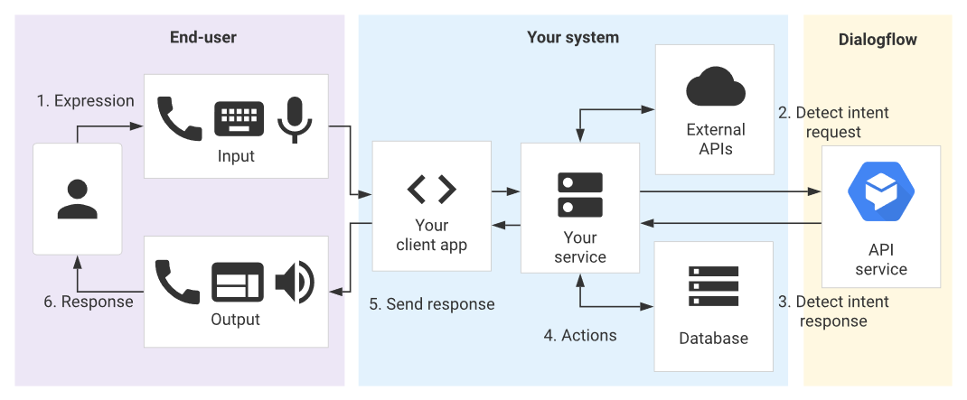Connection Flowchart. Figure 1.1

# The API

The JDBC driver is free software that enables a Java application to interact with SQL Databases, the API is a set of classes that implement JDBC interfaces to process JDBC calls and return sets to a Java application. The database stores the data retrieved by the application using the JDBC Driver.

In the future Techstra-One will also investigate the possibility of connecting Collectstra databases into third-party databases (pending legal rights and third-party agreements.) Techstra-One will use the data obtained from third parties’ databases to provide up to date and accurate pricing for sales and trading information.

Techstra have envisioned a timeline for the application and what the application may be able to do in the future. Techstra-One would like to incorporate database automation, machine learning and potentially using Artificial Intelligence (AI) for uploading cards, or the possibility to have in app games or ‘battles. Techstra-One have acknowledged the importance of streamlined and effective business practices, we believe that with automation, machine learning and AI we can increase overall productivity and positive end user feedback.

# Connection Process

In this paragraph Techstra-One will provide some basic code and procedures followed by some photos for reference on how Techstra-One connects its application to databases. (Screenshots will be gathered using Techstra-One’s database administrators’ virtual machines)

* Loading and registering the JDBC Driver into the application using Java, this is loaded into the memory at runtime.

‘Oracle drive – class.forName(“oracle.jdbc.driver.OracleDriver”);

* DriverManager.registerDrive() this class is inbuilt as a static member; the below code is used to register the Oracle driver.

(DriverManager.registerDriver(new oracle.jdbc.driver.oracleDriver())

* Connecting to the database

Connection con = (String url = “ jdbc:sql:thin:@localhost:1521:ams”)

* Defining a statement, this line of code will define the methods of communication between the application and the SQL.

Statement st = con.createStatement();

* Executing the query, query for retrieving data and query for updating/ inserting table in a database.

int m = st.executeUpdate(sql);

if (m==1)

System.out.println("inserted successfully : "+sql);

else

System.out.println("insertion failed");

Summarised Connection Steps. Figure 1.2

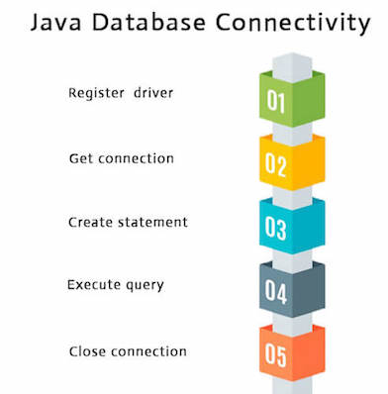

Below is some code for the database connection process. Figure 1.3

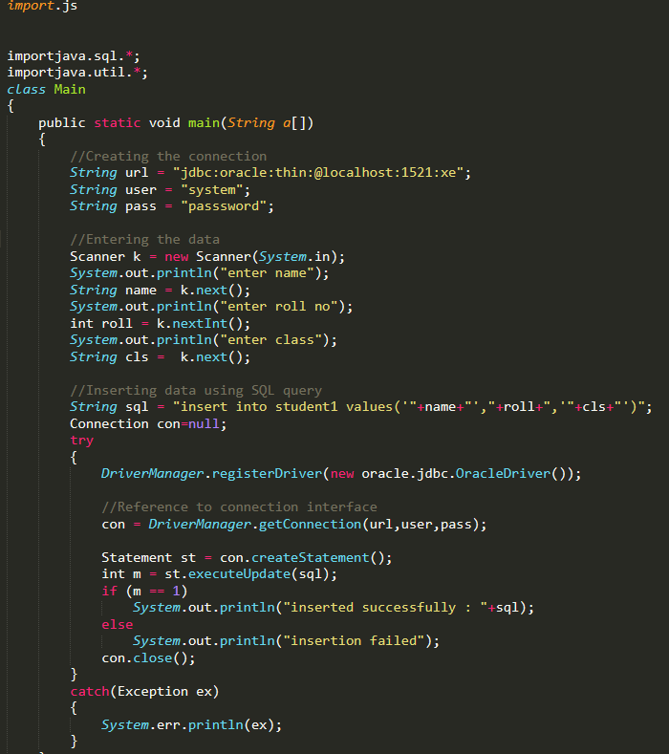

Below is an example of our database, this table below displays users that have connected to the database, this is where their information is saved. Figure 1.4

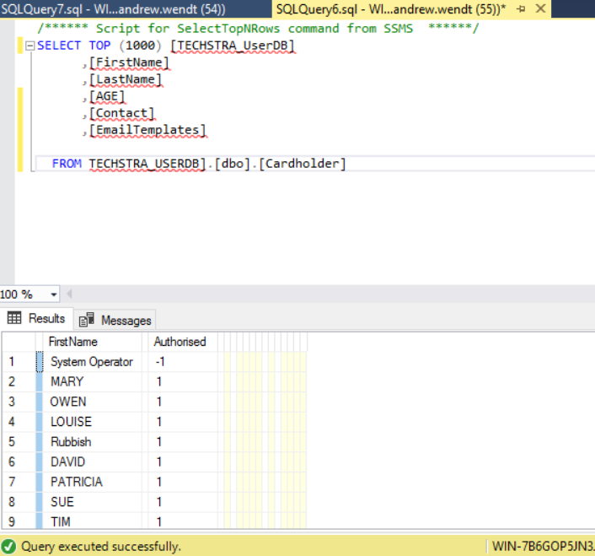

Testing and Development 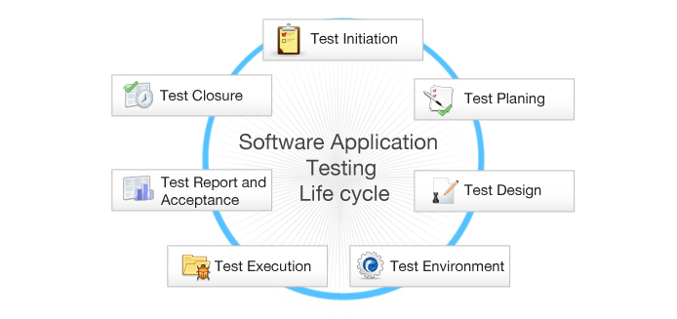

Testing phase figure 1.5

Project testing sequence, extensive testing and development is crucial to the success of our application. To ensure that all issues are settled before deployment here are some procedures that we will be implementing throughout testing and development phases.

**Initiation;** In this stage of testing, Techstra-One will conduct a project management plan, ensuring that all potential risks and issues can be addressed during these stages. It is important that during this stage of the project everyone who needs to be involved is properly engaged to ensure continuity for further stages.

**Test Planning;** how and what we will test to ensure that all parts of the application are covered, ensuring that potential issues or concerns can addressed and rectified in the development stage of the project.

**Test Design;** A test design document will ensure that all elements of the application are tested, and peer reviewed for quality assurance (QA)

**Test Environment;** In this stage of testing, our system administrators will set up a Development Environment (DEV) this environment will be hosted by VMware using virtual machines, Techstra-One have decided that a virtual environment both in testing and production is crucial to the development and success of the application.

The virtual environment will include application servers, database servers and backup servers.Our system administrators will test server load, database connections and backup capabilities. Our application developers will test functional testing in the source code, using ‘black-box’ testing for software. These testing methods will operate in parallel with our testing procedures and design.

**Test Execution;** Executing the code in the DEV environment, in the Alpha stage of testing Techstra-One will follow our strict ‘Test Design’ document ensuring that all elements are tested, documenting each change and ensuring that all issues are captured before the Beta stages of our application.

**Test Report and Acceptance;** In this phase our developers will assess the results and use the data captured from the Alpha phases to continue the next stage of our design. The acceptance phase of testing is to ensure that all data has been reviewed and assessed by all the appropriate stages. Using the test report and data obtained by the testing phase Techstra-One will be able to move forward to ensure that all elements will work correctly.

**Test Closure;** at the end of the acceptance phase Developers alongside with system administrators and project managers will review and assess the data that was captured during the Alpha stages. The project managers will explain lessons learnt, and this information will assist the Beta stage of testing.

Techstra-One have designed our testing procedures for both Alpha and Beta testing phases. The Beta testing phase will be used to assess the operational functions of the application. Techstra-One will select end users that operate android mobile devices. In this phase Techstra-One will assess user data, obtain customer feedback and initiate extensive load testing for further developments.

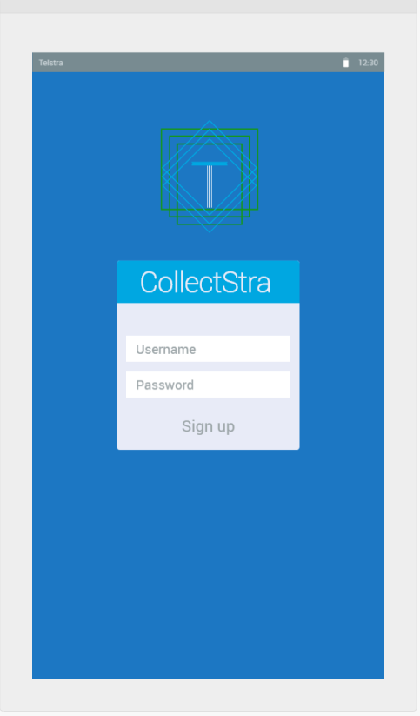

Application Login Screen figure 1.6

# Roadmap

The application is currently designed to operate in Java, but Techstra-One are looking to accommodate all operating systems, including Apple based operating systems. Techstra-One plan to use Complier software that will compile Java code to Objective-C code.

After the Beta stage Techstra-One will make the application available for download on the Google-play store, the application will then go into an operational phase and will be tested and subject to review asking for feedback for future research and development.

Techstra-One are producing a future business case, using the potential success of the application at its foundation, Techstra-One hopes that it may be a lucrative business opportunity for larger companies to partner up and promote their brand through this app.



TechstraOne Roadmap figure 1.7

## References

(**Database Connection Process**) Explaining how to connect to Connection of application to database <https://docs.oracle.com/javase/tutorial/jdbc/basics/connecting.html>.

(Accessed 10/05/2020 – Online)

(**Testing Methods**) Testing of application methods, direct reference of ‘Black-Box’ testing <https://usersnap.com/blog/web-application-testing/>.

(Accessed 10/05/2020 – Online)

Figure 1.1 (**API connection process**) <https://aws.amazon.com/api-gateway/>

(Accessed 12/05/2020 – Online)

Figure 1.2 (**Java database connection process code**) has been edited to suit our application <https://www.javatpoint.com/steps-to-connect-to-the-database-in-java>

(Accessed 12/05/2020 – Online)

Figure 1.3 (Referencing code for screenshot on ‘Sublime’ application.)

<https://docs.oracle.com/javase/tutorial/jdbc/basics/connecting.html>

(Accessed 12/05/2020 – Online)

Figure 1.4 – (**Andrew Wendt**) – Screenshot of test SQL database, displaying user table fields.

Figure 1.5 – (**Testing Methods**)

<https://www.fiverr.com/pinkpinkey/do-software-testing-includes-functional-testing>

(Accessed 12/05/2020 – Online)

Figure 1.6 – (**Techstra-One application GUI**) (Created by Tim Hall, using application https://www.fluidui.com/ for reference.)

Figure 1.7 (**Basic road map for start and end goals**.)

<https://www.istockphoto.com/au/illustrations/road-map?mediatype=illustration&phrase=road%20map&sort=mostpopular>

(Accessed 12/05/2020 – Online)